EXP NO 8 Create a Virtual Machine with 1 CPU, 2GB RAM and 15GB storage disk using a Type 2 Virtualization Software, using virtual box.
DATE:
AIM:
To create a virtual machine with 1 CPU, 2GB RAM, and 15GB storage disk using a Type-2
virtualization software (VirtualBox).
PROCEDURE:
STEP 1: INSTALL ORACLE VIRTUALBOX AS A TYPE-2 HYPERVISOR
STEP 2: DOWNLOAD AN ISO IMAGE FILE OF THE OPERATING SYSTEM (UBUNTU LINUX / WINDOWS).
STEP 3: OPEN VIRTUALBOX → CLICK NEW → CREATE A NEW VIRTUAL MACHINE.
STEP 4: CONFIGURE THE VM
STEP 5: PUT THE PROCESSOR AS 1 AND INCREASE THE MEMORY SIZE AS 15 GB
STEP 6: THEN FINISH THE SETUP
DESIGN:
Design:
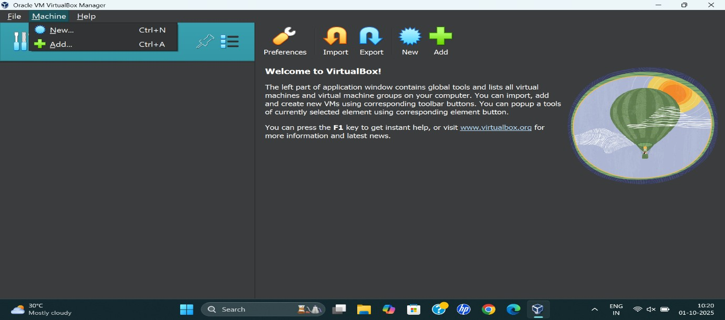

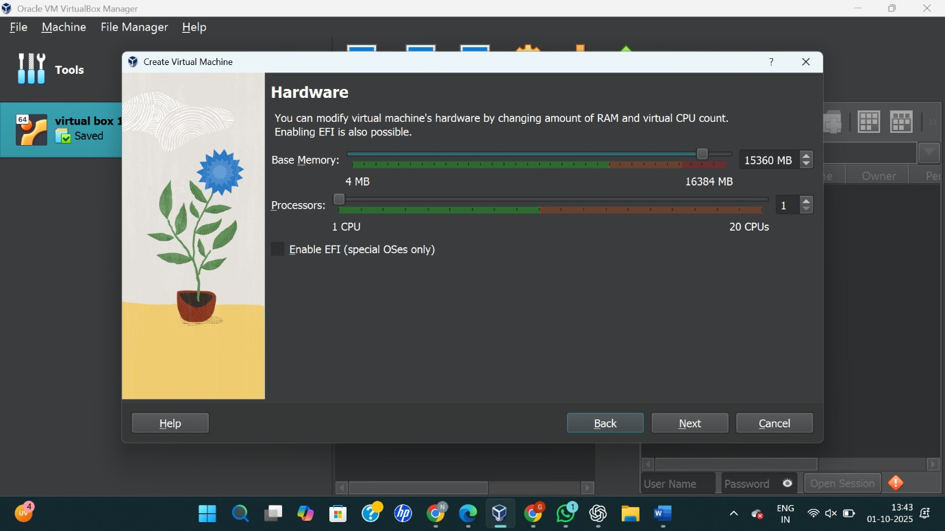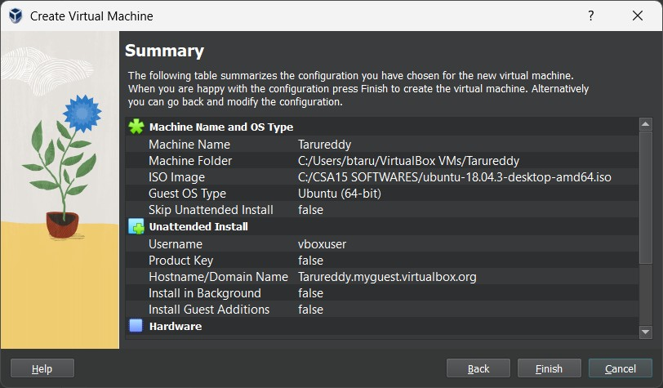
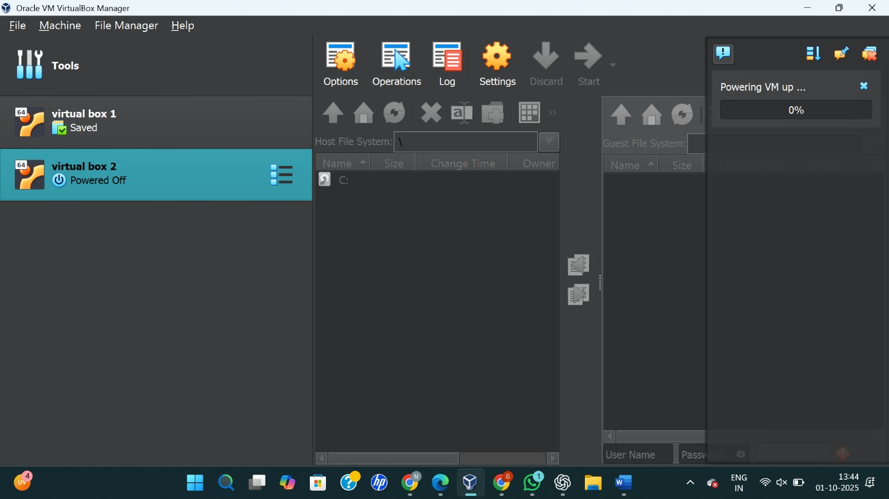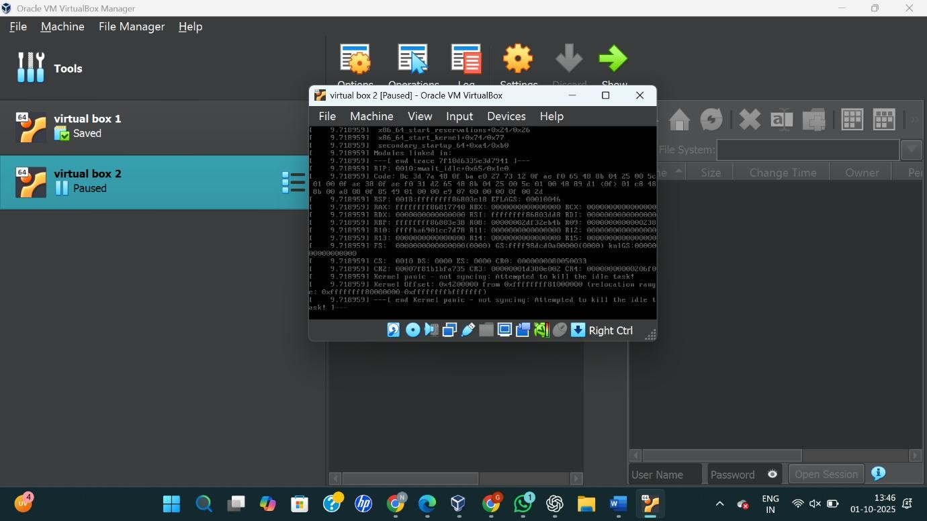

RESULT:
A virtual machine with 1 CPU, 2GB RAM, and 15GB storage disk was successfully created and configured using Oracle VirtualBox (Type-2 Hypervisor).

